Ls Display hidden files
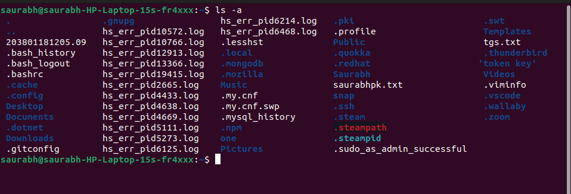

rename Rename all *.txt files to *.htm

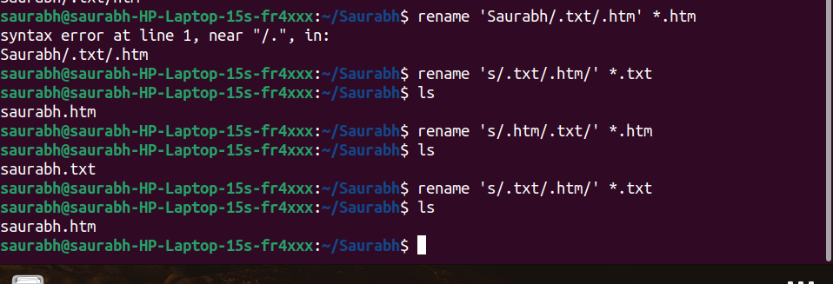

ln -s Create symbolic link (shortcut) for a file

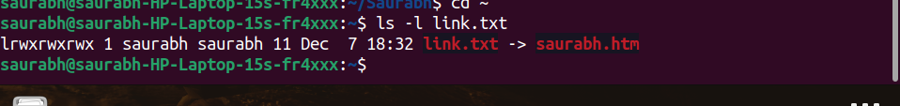

ln Create hard link for a file


stat Display time stamp of the file
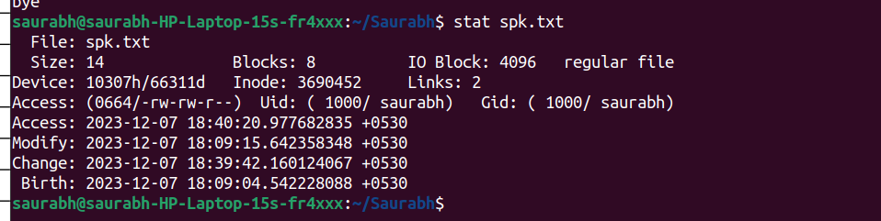

touch Change the time stamp of the file

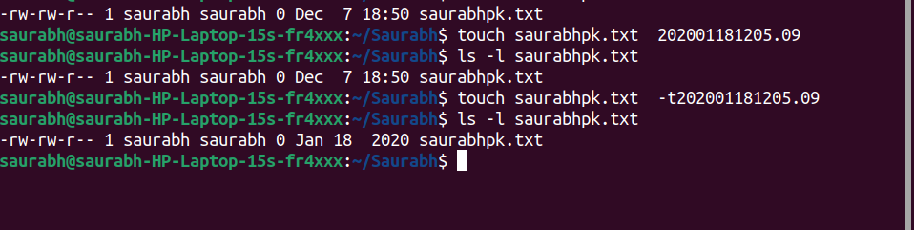

touch Create empty file

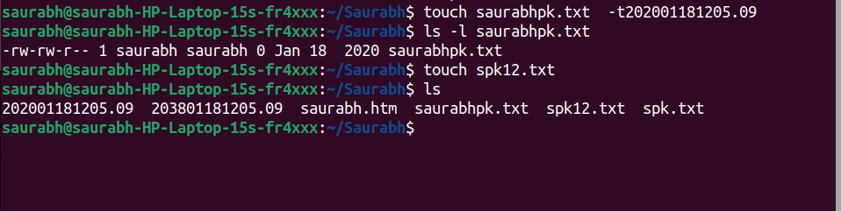

tail Print all lines in a file from fifth line onwards

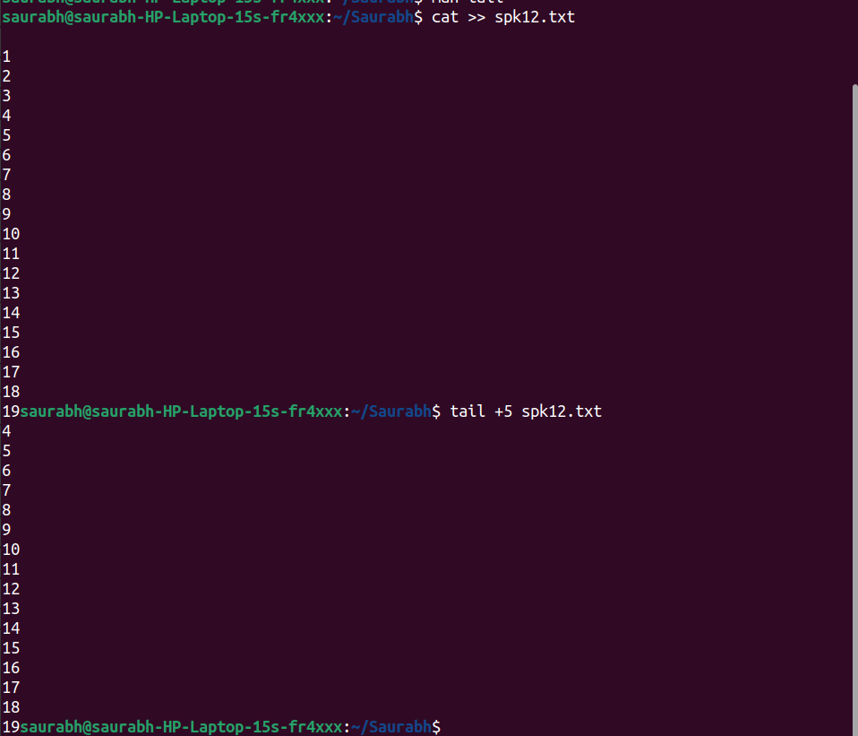

init 0, poweroff

shutsdown th computer

init 6, reboot

restarts the computer

whoami
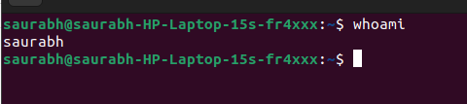

users

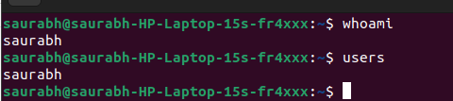

who
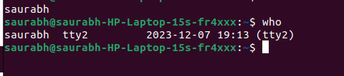

tty

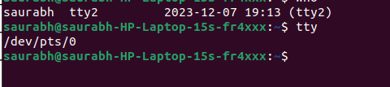

grep, egrep, fgrep
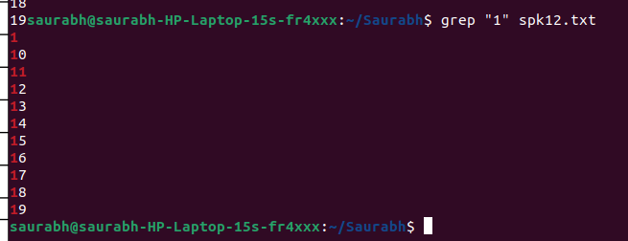
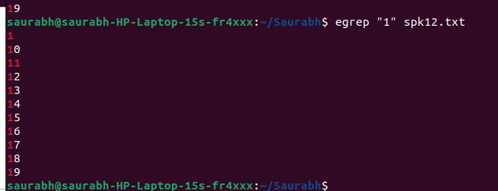
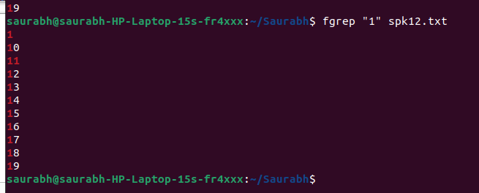

chmod

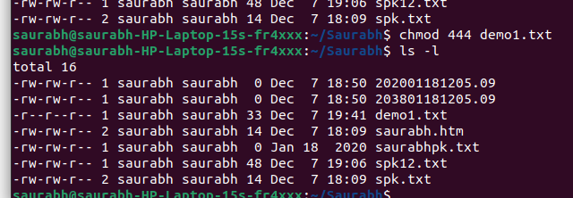

chmod Make a file as write, read and execute

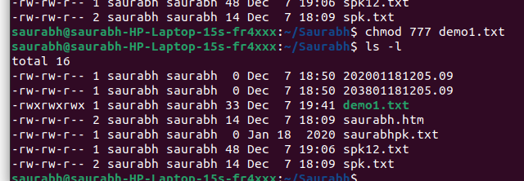

wc (using redirection)

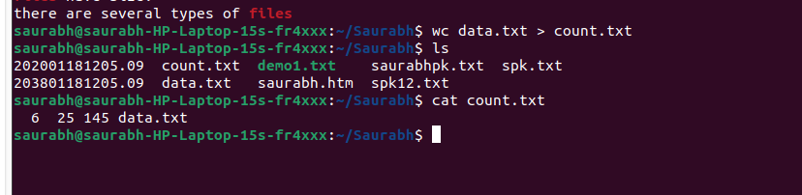

who | wc (using pipe)
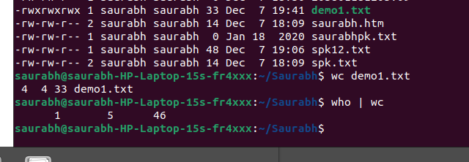

head, tail (using pipe)

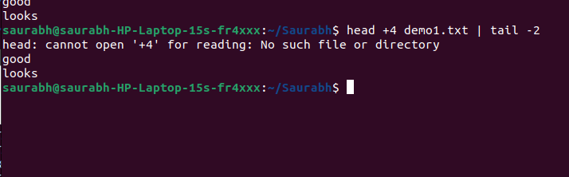
sort , uniq (using pipe)
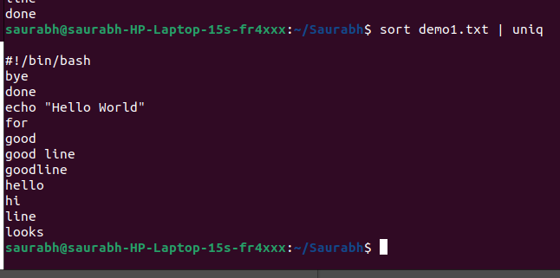

who, grep (using pipe)
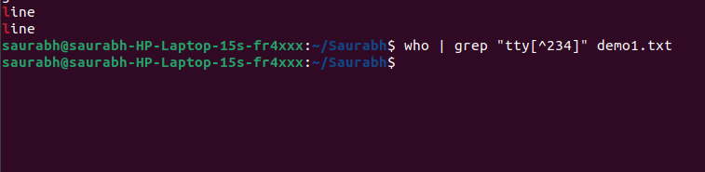

ls
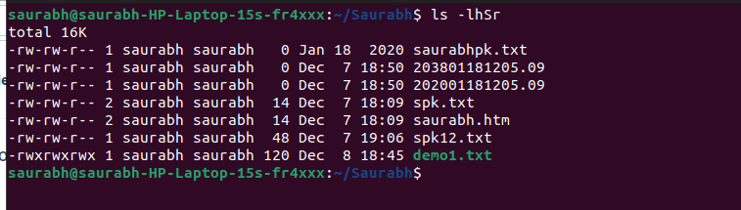

ls, grep (using pipe)

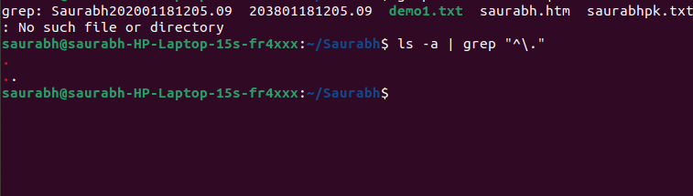

tr
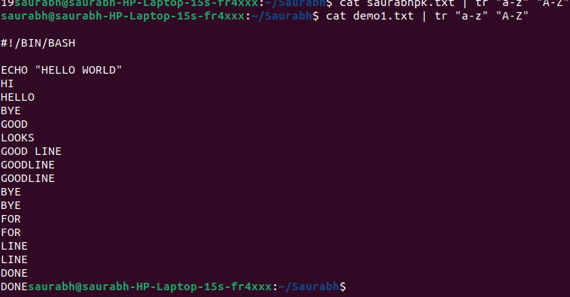

cut
